INSTRUCTION
MANUAL



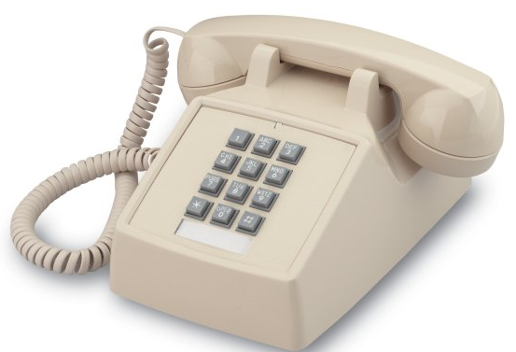
Model: CP08475
CP08476
CP08477
INSTALLING YOUR TELEPHONE
To install your telephone, you must have a modular wall jack at the desired location. The required USOC jack types are RJ11C for desk mounting and RJ11W for wall mounting. The USOC number is printed on the label on the bottom of the telephone.
DANGER: To reduce the risk of electrical shock and personal injury, observe the following precautions.
1. Never install telephone wiring during a lightning storm.
2. Never install telephone jacks in wet locations unless the jack is designed for wet locations.
3. Never touch uninsulated telephone wires or terminals unless the telephone line has been disconnected at the network interface.
4. Use caution when installing or modifying telephone lines.
Desk Telephone - Use the long modular line cord supplied. Plug one end of the line cord into the connector on the back of the telephone and the opposite end into the modular wall jack. To disconnect the telephone, press the spring clip on the line cord plug and pull it out.
Wall Telephone - Insert the modular plug from the short cable in the back of the phone into the wall jack. Align the slotted holes on the back of the phone with the mounting studs on the wall jack. Gently pull down on the telephone until it locks in place. Older versions of the wall telephone may have a gray sliding plug instead of a short cord. Insert this plug into the wall jack and mount as described above.
FEATURES
Volume Control – All these telephones include a handset with receiver volume control that complies with FCC Part 68 requirements mandated by the Hearing Aid Compatibility Act of 1988. The volume control is a small switch found on the inside of the handset.
Pushing the switch toward the upper end of the handset will increase the loudness. Pushing the switch toward the lower end of the handset will decrease the loudness. The volume control will not disable the receiver. The minimum setting of the volume control will usually produce a comfortable listening level for persons with no hearing impairment.
Message Waiting Lamp – This will provide message indication on systems equipped for 90V signaling. (Only on models with message might indicator)
Data Port – The desk versions of this phone have a data port. This jack may be used to connect another device such as a modem or fax to the telephone line.
Ringer – In these phones, the volume control is a small switch. This switch is located on the bottom of the desk phone and switches between high and low volume. The switch is located on the back of the wall phone and is an ON/OFF switch.
The volume control switch is located on the bottom of the desk phone and switches between high and low volume. The wall phones have no volume control.

IMPORTANT SAFETY INSTRUCTIONS
Always follow basic safety precautions when using your telephone equipment to reduce the risk of fire, electrical shock, and injury.
1. Read and understand all instructions in the Owner’s Instruction Manual.
2. Read all warnings and follow all instructions marked on the product.
3. Unplug this product from the wall outlet before cleaning. Use a damp cloth for cleaning. Do not use liquid or aerosol cleaners.
4. Do not use the telephone near water. For example, do not use near a bathtub, wash bowl, kitchen sink, laundry tub, swimming pool, or in a wet basement.
5. Do not place this product on an unstable cart or stand. The product may fall causing serious damage to the product.
6. Do not place any objects on the telephone line cord. Do not locate the telephone where the line cord will be walked on.
7. Do not block or cover ventilation slots and openings in the bottom of the telephone. The openings should never be blocked by placing the telephone on a bed, sofa, rug, or other similar surfaces. This telephone should never be placed near or over a radiator or heat register. This telephone should never be placed in a built-in installation unless proper ventilation is provided.
8. Never spill liquid on the telephone or push objects of any kind through ventilation slots. Liquid or objects may touch dangerous voltage points or short out parts that could result in a risk of fire or electrical shock.
9. Do not disassemble this product. Opening or removing covers may expose you to dangerous voltages or other risks. Incorrect reassembly can cause electrical shock when the product is subsequently used.
10. Avoid using a telephone during a local thunderstorm. There may be a remote risk of electrical shock from lightning.
11. Do not use a telephone in the vicinity of a gas leak to report the leak, or otherwise.
12. Unplug the telephone from the wall outlet and refer servicing to qualified service personnel under the following conditions:
• When the line cord is frayed or plugs damaged.
• If liquid has been spilled into the telephone.
• If the telephone has been exposed to rain or water.
• If the telephone does not operate properly by following the operating instructions.
• If the telephone has been dropped or the housing damaged.
• If the telephone exhibits distinct change in performance.

